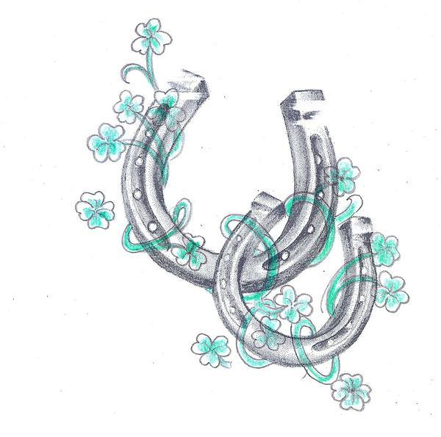  Contact Us  April Pearson (Owner and CEO)  Phone: (270)-564-7177  Email: apdawn3810@gmail.com  Facebook: A&A Horse Haven  https://m.facebook.com/AA-horse-haven-244018666842573/  A&A Horse Haven Informational Brochure  Boaz, KY |  |  | Get a life, Get a horse!  Who We Are  About Us  Our mission here at A&A Horse Haven is to be the voice, the aid, the help, the friend, and the advocate for the horse since they cannot do it themselves. We are a nonprofit equine rescue that focuses on saving horses from auctions that do not have a home prospect. We also provide help and aid to the sick, abused, neglected, unwanted, and starving horses. We specialize in rehabbing, refeeding, and rehoming these horses. We will be their voice because they don’t have one. |  |  | A&A Horse Haven Informational Brochure  - We save Horses! What is Your Super Power?  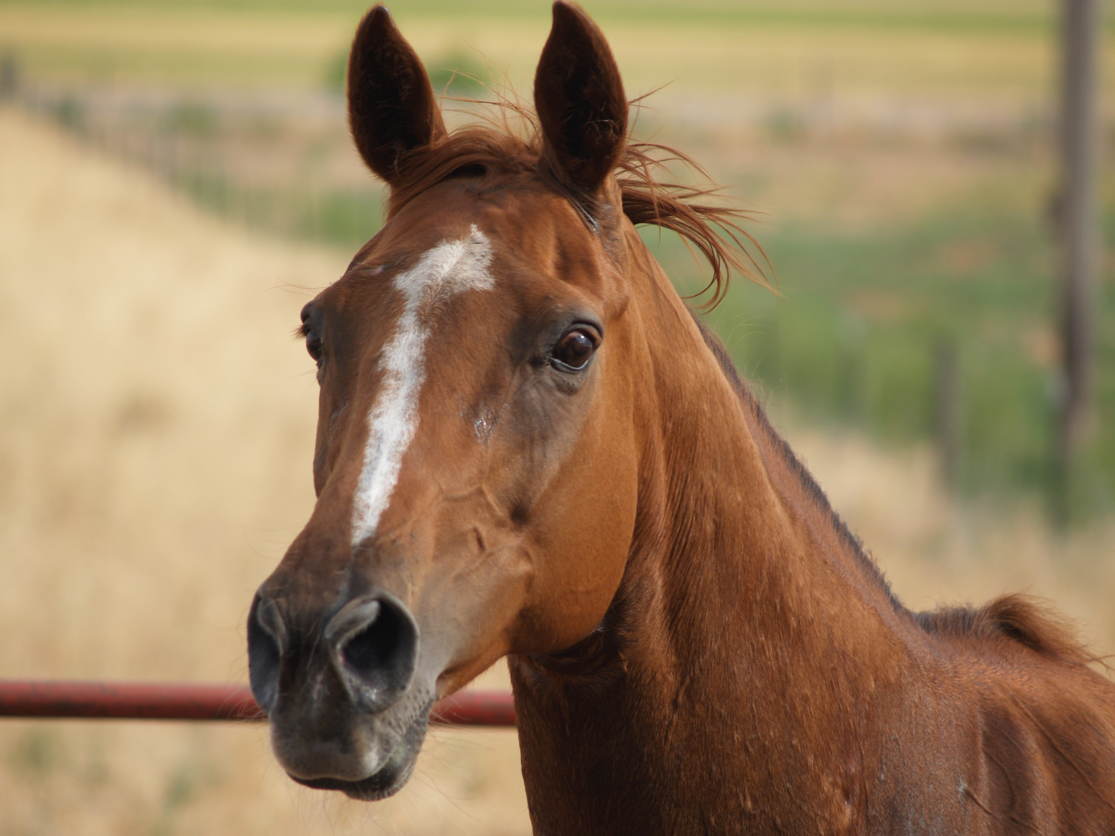

Checklist for your horse:  - Halter/ Lead rope  - Fly Spray  - Fly Sheet  - Fly/ UV mask  - Winter Blanket  - Brushes/ Combs  - Shampoo/Conditioner  - Hoof Pick  - Clean Water Daily  - Food/ Hay  - Treats  - Salt/Mineral Block  - Sunscreen  - Horse Wormer  - Coggins Test  - Veterinarian  - Farrier  Bringing your Horse Home:  - Adequate turn-out space  - Refuge from weather  - Emergency Plan  - Health and Safety needs  - Feeding Schedule  - Learn Signs of Colic and the different types  - Learn signs of Choking |  |  | A&A Horse Haven  Health Concerns to learn:  - Runny nose with color  - Watch for changes in body weight  - Signs or pain or discomfort  - Routine hoof care  - Routine Vet checks  - Immunizations  - Body Language  - Age appropriate diets  - Skin Care  Helpful Tips:  - Learn your horses actions  - Routine grooming  - Be courteous to your horse  - When traveling be cautious letting your horses strange buckets  - Check on horse several times daily  - Create a bind with your horse  - Earn its trust  - Be patient  - Be calm |  |  | Diseases to watch for in your horses:  - Rain Rot: Common bacterial skin disease in horses; Characterized by matted hair and skin lesions that ooze and form clumps.  - Rabies: Horses can get rabies by being bitten by a rabid animal. Such as skunk, fox, or raccoon.  - Ringworm: common fungal skin infection of many animal species. Horses show circular patches of hair loss with crusting and scaling of the skin. Can be transmitted from skin to skin contact with the area can contact it.  - Other diseases to look for are salmonellosis, anthrax, brucellosis and leptosposis.  Also do your research.  Websites/Magazines we recommend for research:  - Merk Vet manual  - Thehorse.com  - Horse side vet guide  - saddleupSAFTEY.com  - theHorse  - Carson James Videos  - WebMDvets.com

